HUMAN BIOLOGICAL SCIENCE
UNIT 3AHBS
Human form and function
Cells, metabolism and regulation
Cellular activities are controlled by feedback mechanisms for the maintenance of homeostasis of body temperature, body fluid composition, blood sugar, gas concentrations and blood pressure. Disruption to homeostasis causes dysfunction that can be controlled by physiological and behavioural mechanisms, and medical intervention.

Cellular activities:
- role of cell membrane structure and function in active transport and as a receptor
- DNA controls the production of cellular materials.

Homeostasis by feedback systems:
- components of a stimulus-response feedback model
- homeostatic mechanisms that control
- body temperature
- body fluid composition including the role of the nephron
- blood sugar
- gas concentrations
- blood pressure
- physiological and behavioural mechanisms that influence the maintenance of homeostasis of the above conditions.

Disruption of homeostasis:
- causes of disruption
- hormonal including diabetes
- behavioural including drugs, exercise and diet
- disease including thyroid dysfunction
- treatments for disruption of homeostasis.
Body systems
The endocrine and autonomic nervous systems work together to control the interaction of body systems to maintain homeostasis in a changing external environment.

Endocrine system:
- types and location of endocrine glands including pituitary, thyroid, parathyroid, pancreas, adrenal glands, gonads
- relationship between the hypothalamus and pituitary
- production site, target organ and effect of hormones associated with the specified glands
- feedback loops involving endocrine activity
  - regulation of metabolism
  - regulation of blood sugar
  - regulation of body fluid composition
- hormonal modes of action—cell recognition
  - lipid soluble—steroid hormones
  - water soluble—amine hormones.

Autonomic nervous system:
- overview of divisions of the nervous system
- relationship of the Autonomic NS to the body’s nervous system
- divisions of the Autonomic NS and their effect on various body organs.

Comparison of hormones and nerves in terms of:
- speed, duration, transmission and specificity.

Human diversity and change
Inheritance
Variations in characteristics can arise from gene expression or be the result of polygenes.

- the effect of the environment on gene expression including effect of UV light exposure on melanin production
- epigenetics
  - mechanisms including histone modification and DNA methylation/acetylation
  - case studies including twin studies.
- polygenic inheritance including human skin colour.

Variation and evolution
Gene pools are affected by evolutionary mechanisms including natural selection and chance occurrences. The main evidence for evolution comes from comparative studies in anatomy and biochemistry, and the fossil record.

Gene pools:
- changes in allele frequencies due to:
  - mutation
  - natural selection
  - random genetic drift including the founder effect
  - migration
  - barriers to gene flow
  - incidence of genetic diseases in various populations including Tay-Sachs disease and sickle-cell anaemia.

Speciation:
- theory of evolution by natural selection.

Evidence for evolution:
- comparative studies:
  - DNA
  - protein sequences
  - anatomy including embryology, homologous structures and vestigial organs
- the fossil record:
  - fossil formation
  - geological dating and its limitations
  - relative dating including stratigraphy, index fossils and fluorine dating
  - absolute dating including C–14 dating
- awareness of problems with the fossil record.

The practice of human biology
Approaches to investigating and communicating human biology
- use a problem identified by the student to formulate an hypothesis
- plan and conduct a safe and ethical investigation incorporating two different methods to collect data
- simple analysis of results including factors that influence the investigation, graphs, rates, percentages and frequencies
- refer to other researchers’ findings to analyse and report data using a variety of sources of supporting evidence and scientific concepts.

The relevance of human biology to everyday life
Human intervention can occur during stages of life by manipulation of life processes. This enables control of normal function or development and treatment of dysfunction to influence the quality of life for individuals and the society.

Control of homeostatic dysfunction and hormone replacement therapies to assist treatment of:
- hyper/hypothyroidism
- diabetes.

Risks and benefits associated with interventions.

UNIT 3BHBS
Human form and function
Cells, metabolism and regulation
DNA codes for the production of proteins in cells via a series of processes. Humans have specific resistance mechanisms, in response to an invasion by pathogens.

DNA and RNA is involved in:
- protein synthesis (including transcription and translation)
- cellular control of gene expression including regulator and promoter genes.

Specific resistance:
- role of B cells, T cells, memory cells and plasma cells
- antibody and cell-mediated defence
- primary and secondary immune response
- passive and active immunity
- natural and artificial immunity
- role of antibiotics and antivirals.

Body systems
The nervous system and the musculo-skeletal system interact to provide coordinated actions of the body. Advances in medical technologies can enhance body functions and replace structures to alter the natural course of human development and aid recovery after trauma.

Central and peripheral nervous system:
- brain (cerebrum, cerebellum, meninges, medulla oblongata, hypothalamus), spinal cord
- afferent and efferent systems
- structure of motor, sensory and inter-neurons
- the reflex arc including components and their functions in the transmission of messages
- transmission of nerve impulses—generation and propagation
- control of movement and balance—areas and types of motor control of the body in the cerebrum and cerebellum
- innervation of muscular contraction.

Muscles—structure and function related to:
- macroscopic including the types (voluntary, involuntary) and movements
- microscopic including myofibrils
- molecular including actin and myosin
- sliding filament theory of contraction.

Skeleton—structure and function related to:
- macro and microscopic structure of bone and cartilage
- structure and functionality of major joint types including ball and socket, hinge, pivot, gliding, immovable, cartilaginous.

Effects of ageing on the nervous and musculo-skeletal systems:
- Alzheimer's disease
- Parkinson's disease
- osteoporosis
- osteoarthritis.

Medical technologies used to treat effects of ageing and trauma on the nervous and musculo-skeletal systems:
- tissue regeneration
- stem cell therapy
- artificial replacements.

Human diversity and change
Inheritance
Biotechnological techniques are being developed and used for a range of applications including identification of hereditary diseases.

- techniques including definition, process and examples of use
  - DNA sequencing
  - profiling techniques
  - PCR (polymerase chain reaction)
  - genetic probes
- production of human proteins, hormones and vaccines by DNA recombinant techniques including restriction and ligase enzymes
- treatment of genetic disorders by gene therapy
- cell replacement therapy and tissue engineering by the cloning of stem cells.

Variation and evolution
Within the classification system, primate and hominin groups show evolutionary trends. Human evolution is the result of interaction of evolutionary mechanisms and the environment.

Primate evolutionary trends:
- relative size of cerebral cortex
- olfactory/optical shift
- gestation time and parental care
- mobility of the digits
- teeth shape and dental arrangements.

Hominin evolutionary trends:
- bipedalism—feet adaptations, hip and knee joints
- relative size of cerebral cortex
- prognathism and dentition
- spine and pelvis shape.

Interaction of evolutionary mechanisms and the environment:
- effects of environment on early hominin evolution
- significant cultural advances associated with australopithecines, Homo habilis, Homo erectus, Homo neanderthalensis, and Homo sapiens including tool cultures and the change in lifestyles up to and including the development of agriculture.

The practice of human biology
Approaches to investigating and communicating human biology
- use a personally identified problem to formulate an hypothesis
- select methodology to plan and conduct a safe and ethical investigation into various aspects of the problem
- mathematically justify results and use others’ results to support findings
- justify conclusions taking into account errors and limitations in data
- prepare and present a balanced report, including discussion of limitations and biases, using information from scientifically reliable sources as well as own data.

The relevance of human biology to everyday life
The human genome can be used for individualising medical interventions. Human lifespan is increasing causing issues associated with an ageing population.

Potential treatment related to individual variations:
- information from the Human Genome providing new interventions for common dysfunctions/ disorders
- gene therapy
- tissue regeneration.

Risks, ethical concerns and benefits:
- production and use of vaccines and hormones
- medical technologies for treating the effects of ageing.

Human life span:
- diseases and treatment of an ageing population
- euthanasia and quality of life issues.

Examination design brief

Stage 3

Time allowed
Reading time before commencing work: ten minutes
Working time for paper three hours

Permissible items
Standard items: pens (blue/black preferred), pencils (including coloured), sharpener, correction fluid/tape, eraser, ruler, highlighters
Special items: non-programmable calculators approved for use in the WACE examinations

Section | Supporting information
Section One  Multiple-choice  30% of the total examination  30 questions  Suggested working time: 40 minutes | Stimulus material could include text, diagrams, second-hand data and graphs.
Section Two  Short answer  50% of the total examination  6–10 questions  Suggested working time: 90 minutes | Questions could require the candidate to recount, explain or interpret information.  Stimulus material could include text, diagrams, second-hand data and recent research material.
Section Three  Extended answer  20% of the total examination  2 questions from a choice of 3  Suggested working time: 50 minutes | Questions could include stimulus materials such as text, diagrams, second-hand data and recent research findings.  The candidate’s responses could include clearly labelled diagrams with explanatory notes; lists of points with linking sentences; clearly labelled tables and graphs; and annotated flow diagrams with introductory notes.

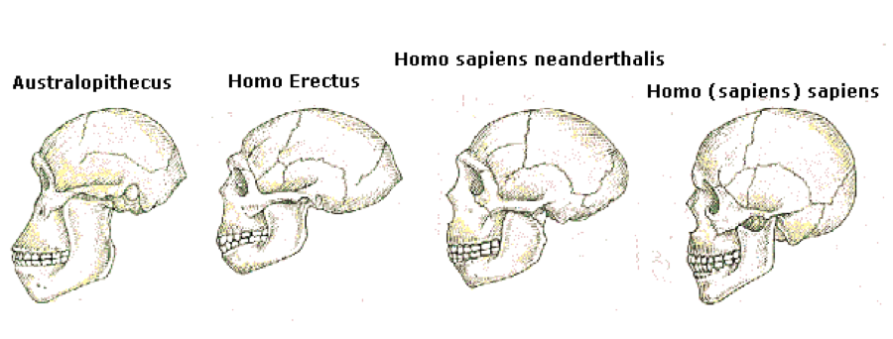
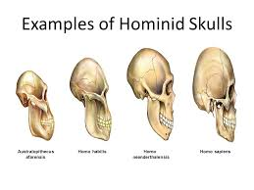
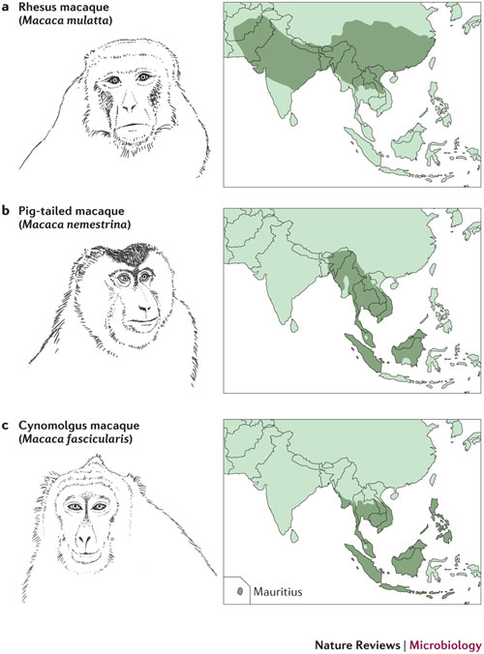
a | The geographical range of the rhesus macaque (Macaca mulatta) exceeds that of all other primate species except humans, extending from western India and Pakistan across China. Distinct populations of rhesus macaques can be differentiated on the basis of mitochondrial DNA sequences or SNPs^{203, 204}. Captive-breeding programmes in the United States were initially established using animals imported from India, contributing to the widespread use of Indian-origin rhesus macaques in AIDS research. However, owing to the increasing demand for rhesus macaques and an embargo on the exportation of these animals from India since 1978, there has been a substantial decline in their availability and a sharp increase in their cost. This has led to greater dependence on rhesus macaques imported from China and Burma. b | The pig-tailed macaque (Macaca nemestrina) is native to Southeast Asia, Malaysia and Indonesia, and last shared a common ancestor with rhesus macaques approximately 3.5 million years ago²⁰⁵. c | The cynomolgus macaque (Macaca fascicularis), also known as the long-tailed or crab-eating macaque, is native to regions of Indochina, Malaysia, Indonesia and the Philippines. Genetic evidence suggests that cynomolgus and rhesus macaques diverged from a common ancestor approximately 1.9 million years ago^{204, 205}. Distribution data from Ref. 206.

